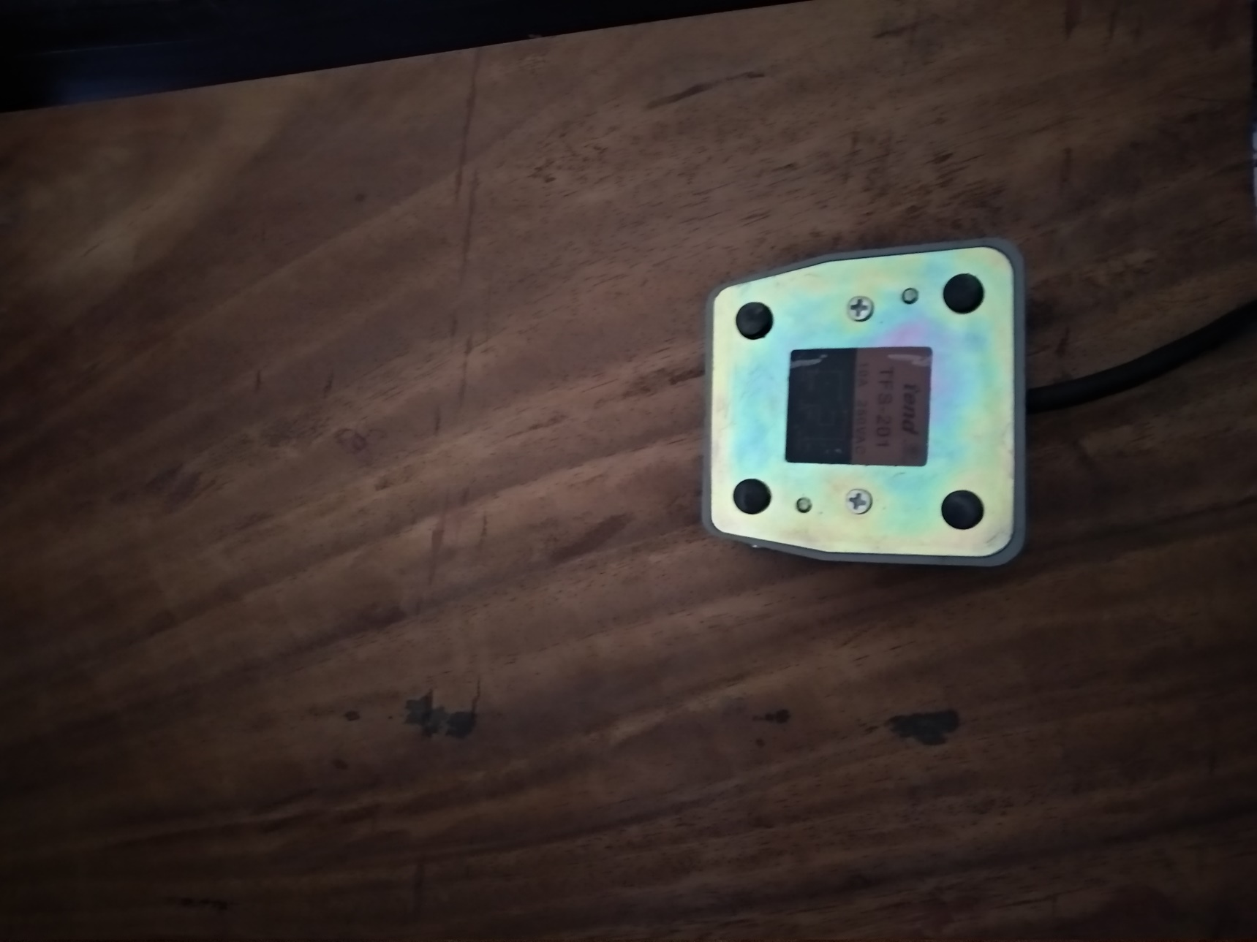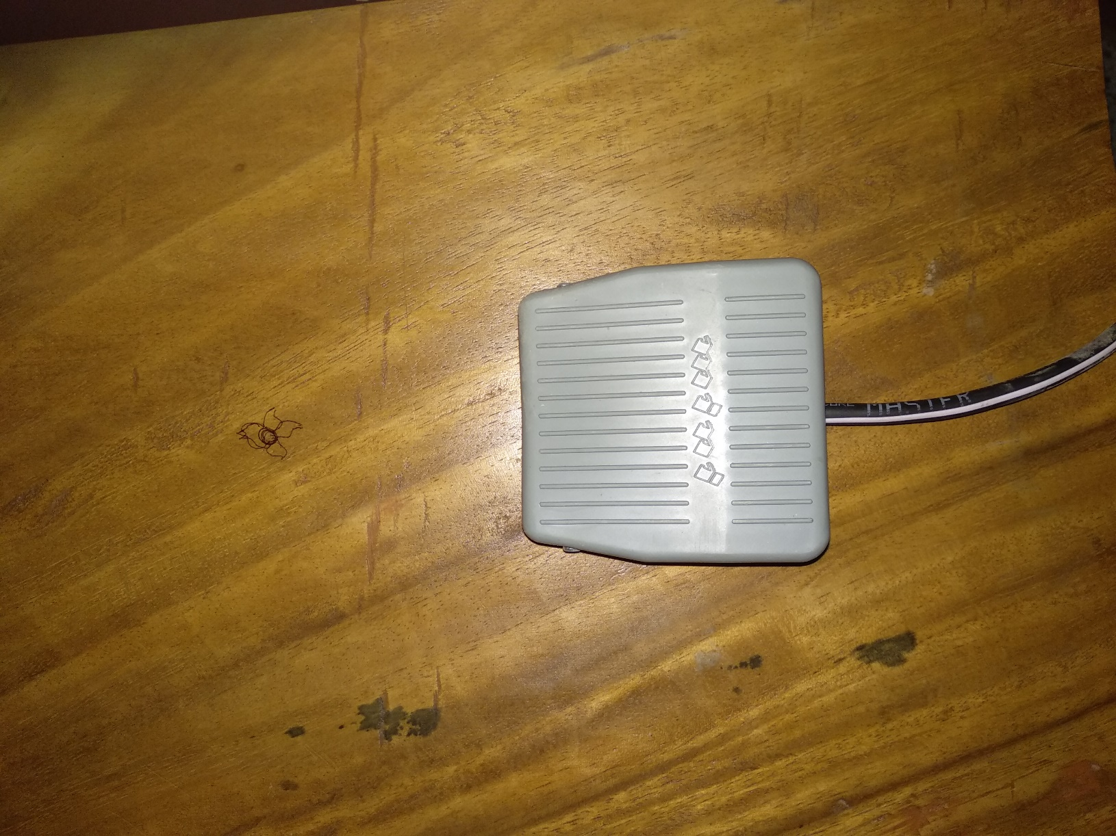

Figure 3.3: Paddle of Surgical Diathermy machine (National Electrocare- 250MB)

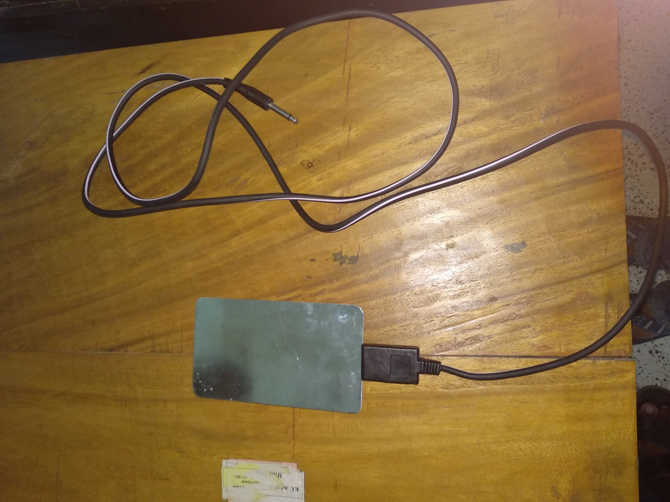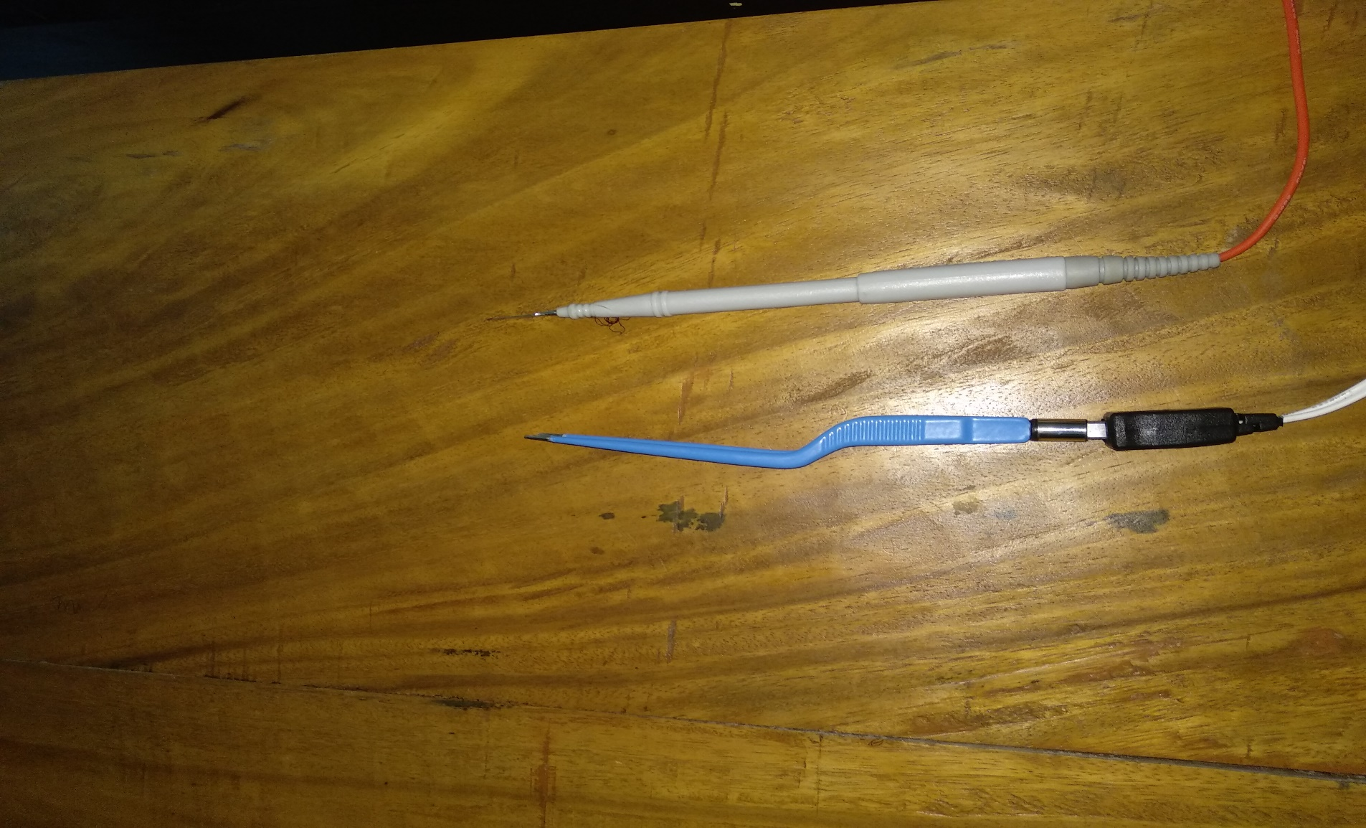

Figure 3.5: Equipment of Surgical Diathermy machine

Figure 3.4: Surgery equipments of Surgical Diathermy machine (National Electrocare- 250MB)

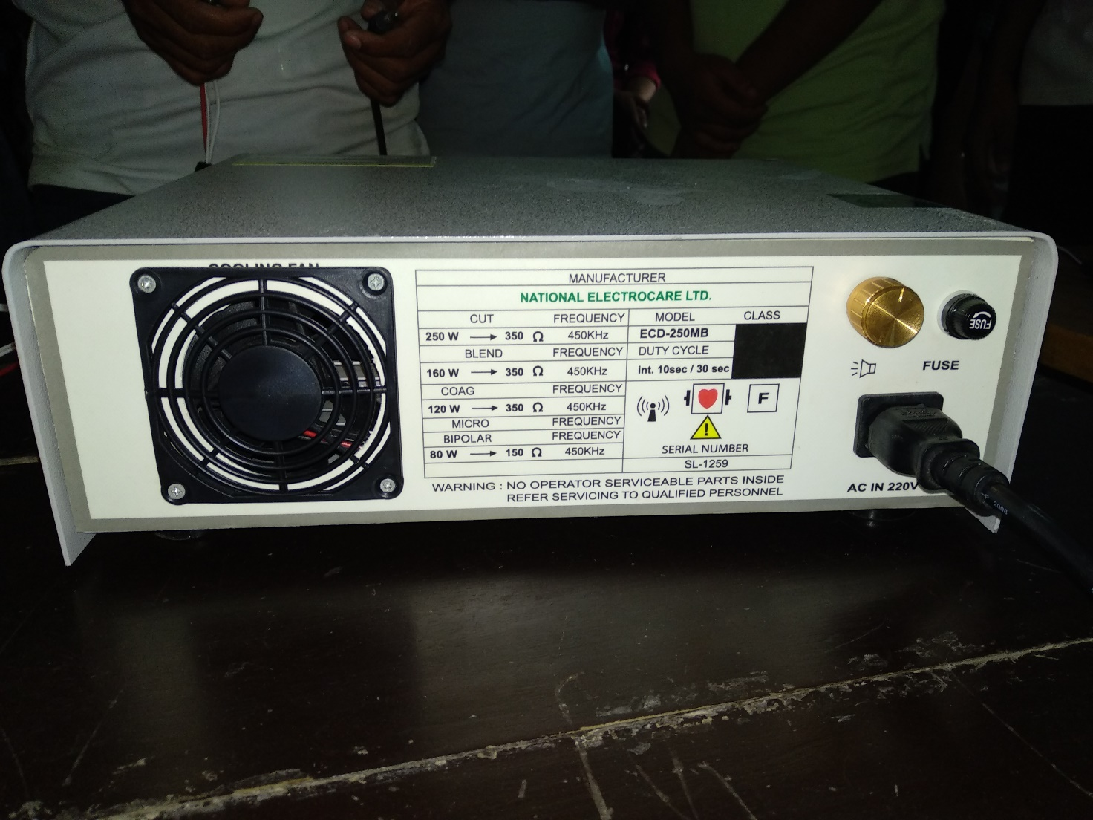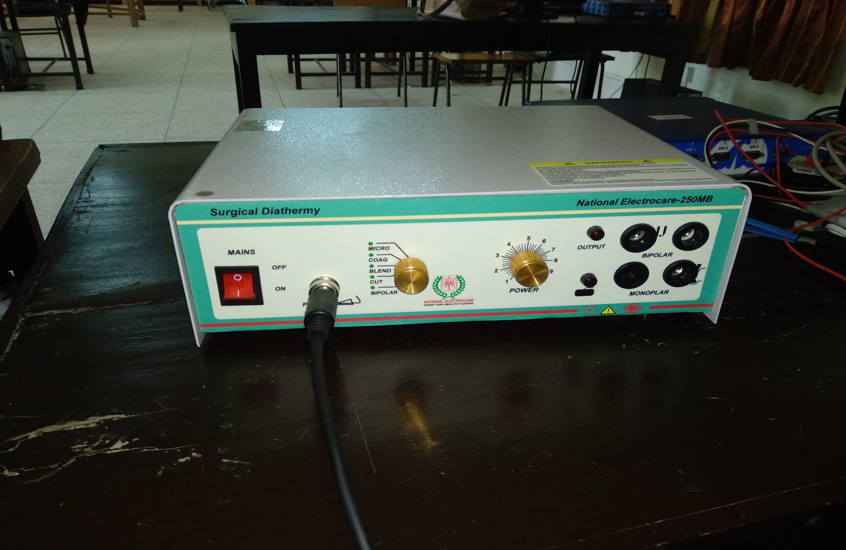

Figure 3.2: Specification of Surgical Diathermy machine (National Electrocare- 250MB)

Figure 3.1: Surgical Diathermy machine (National Electrocare- 250MB)